Moorhouse Group Ltd

Question Set Specification

For Tradesman Liability Product

**Document Control**

|  |  |
| --- | --- |
| Document Purpose | The purpose of this document is to provide a functional and design specification for the Liability Product Data Capture for the Moorhouse Group. |
| Document Reference | Question Set Specification for Tradesman Liability Product |
| Date of Document Creation | Jan 2025 |

**Confidentiality Notice**

This document is strictly private and confidential and for use by the Moorhouse Group.

Table of Contents

1 Introduction 4

2 Client Search 4

3 Product Selection 4

4 Client Details 4

5 Data Capture Navigation 7

6 Product Data Capture 8

6.1 TRADESMAN LIABILITY 8

8.1.1 Trade Details 8

8.1.4 Partners and Principals 17

Claim Detail 21

Assumptions 23

# Introduction

This specification has been produced to set out the data capture screens for the Tradesman Liability product.

# Client Search

After logging into Transactor, in order to capture any product details the associated client must either already exist or be created. Transactor will present the Client Search screen (refer to ‘Client Search’ section within the Core Specification). From which the ‘New Client’ option can be selected.

# Product Selection

Upon selection of ‘New Client’, the following Product Selection screen is presented, from here the required Agent, Product Sub Agent are selected.

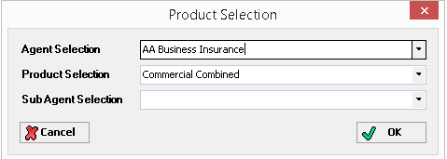

# Client Details

The Client Details screen will be configured to default to ‘Company’ format. The screen below represents the standard Transactor <*Client Details*> screen in ‘Company’ format, the option to toggle to the ‘Private Individual’ format is available.

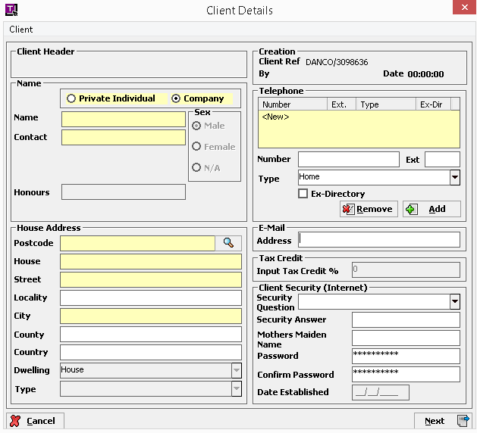

Disabled fields will appear greyed out.

The following buttons will be available:

|  |  |
| --- | --- |
| **Button** | **Comments** |

|  |  |
| --- | --- |
| Cancel | Returns to the <Client Search> screen. |
| Next | Will proceed to the first data capture screen for the selected product.  CONFIGURATION NOTES:  The standard ‘Target Price, ‘Cross Sales Information’ and ‘Contact and Marketing Information’ screens will be configured to appear at the end of Product data capture  Target Price ‘Current Renewal Date’ will be defaulted to system date |

The following menu items will be available:

|  |  |
| --- | --- |
| Menu Item | Comments |

|  |  |
| --- | --- |
| Client | Presents a dropdown offering the following:  Business Details  Notes |

# Data Capture Navigation

The risk data for each product is captured over a number of screens.

The ‘Tradesman Liability’ product is represented in the diagram below where each box indicates a screen. The darker screens represent the ‘Parent’ screens; each parent may have one or more associated ‘Child’ screens.

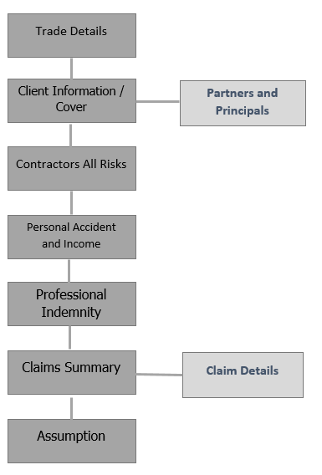

When a user selects NEXT from a parent screen, they will progress to the next parent screen (as indicated by the vertical lines). In the same way, selecting PREVIOUS will return the user to the previous parent screen.

# Product Data Capture

## TRADESMAN LIABILITY

## 8.1.1 Trade Details

This is the first risk data capture screen.

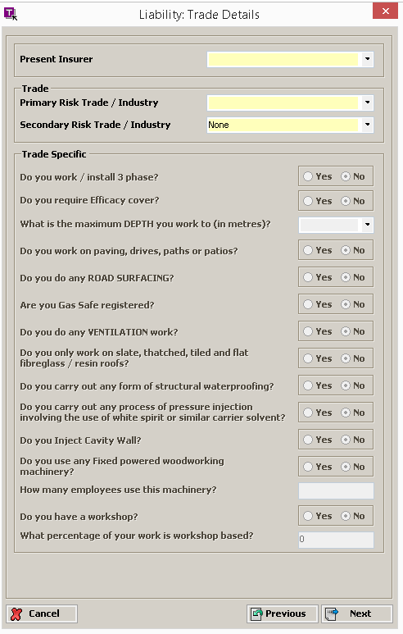

The following fields will be presented:

|  |  |  |
| --- | --- | --- |
| **Field Heading** | **Comments** | **Ref** |

|  |  |  |
| --- | --- | --- |
| Present Insurer | LIST_INSURER (ABI LIST 81)  **Values:** Standard ABI list |  |

**Trade**

|  |  |  |
| --- | --- | --- |
| Primary Risk Trade / Industry | LIST_MH_TRADE **(NEW)**  **Values:** As Product_Trade.xls  Will default to the Business Description as held against the ‘Client / Business Details’ screen |  |
| Secondary Risk Trade / Industry | LIST_MH_TRADE **(NEW)**  **Values:** As Product_Trade.xls  Will default to the Secondary Business as held against the ‘Client / Business Details’ screen |  |

**Trade Specific**

|  |  |  |
| --- | --- | --- |
| Do you work / install 3 phase? | Disabled – see rules  Yes / No option |  |
| Do you require Efficacy cover? | Disabled – see rules  Yes / No option |  |
| What is the maximum DEPTH you work to (in metres)? | Disabled – see rules  LIST_MH_MAXDEPTH **(NEW)**  **Values:** 1,2,3, 4+ |  |
| Do you work on paving, drives, paths or patios? | Disabled – see rules  Yes / No option |  |
| Do you do any ROAD SURFACING? | Disabled – see rules  Yes / No option |  |
| Are you Gas Safe registered? | Disabled – see rules  Yes / No option |  |
| Do you do any VENTILATION work? | Disabled – see rules  Yes / No option |  |
| Do you only work on slate, thatched, tiled and flat fibreglass/resin roofs? | Disabled – see rules  Yes / No option |  |
| Do you carry out any form of structural waterproofing? | Disabled – see rules  Yes / No option |  |
| Do you carry out any process of pressure injection involving the use of white spirit or similar carrier solvent? | Disabled – see rules  Yes / No option |  |
| Do you Inject Cavity Wall? | Disabled – see rules  Yes / No option |  |
| Do you use any Fixed powered woodworking machinery? | Disabled – see rules  Yes / No option |  |
| How many employees use this machinery? | Disabled – see rules  3 numeric characters |  |
| Do you have a Workshop? | Disabled – see rules  Yes / No option |  |
| What percentage of your work is Workshop based? | Disabled – see rules  3 numeric characters |  |
| Do you Manufacture, Process (including cutting/grinding) or Supply any Kitchen Worktops (or any other similar products)? | Disabled – see rules  Yes / No option | Refer if yes |
| Please confirm that you have ensured that:     * any exposure to stone dust (particularly silica dust) is adequately controlled using engineering methods such as water suppression and local exhaust ventilation, and * suitable controls are provided for all manufacturing, grinding, and cutting activities, irrelevant of duration and location (indoors or outdoors) and * adequate and suitable Personal Protective Equipment (PPE) Respiratory Protective Equipment (RPE) is available for use by all employees and * any RPE is appropriate, adequate, properly maintained and its use enforced * there is the provision of information, instruction, and training to employees on the risks and control measures required. | Disabled – see rules  Yes / No option |  |

The following rules will be applied:

|  |  |
| --- | --- |
| **Rule** | **Ref** |

**Trade Specific**

|  |  |
| --- | --- |
| Enable ‘Do you work / install 3 phase?’ when the value of either ‘Primary Risk Trade/Industry’ or ‘Secondary Risk Trade/Industry’’ is DEVELOPER   * Electrical Contractors * Electricians |  |
| Enable “ Do you require Efficacy cover?” when the value of either “Primary risk trade/industry or Secondary trade of industry is:   |  | | --- | | Alarm Installers | | CCTV Installation | | Electrical Contractors | | Electricians | |  |
| Enable ‘What is the maximum DEPTH you work to (in metres)?’ when the value of either ‘Primary Risk Trade/Industry’ or ‘Secondary Risk Trade/Industry’ is DEVELOPER   * Alarm Installers * Flooring Contractors * Groundworkers * Telephone System (Including wireless signalling installations) & Data Cabling Installers * Paving, Path, Drive & Patio Contractor * Landscape Gardeners * Landscape Gardeners (Including tree felling / lopping) |  |
| Enable ‘Do you work on paving, drives, paths or patios?’ when the value of either ‘Primary Risk Trade/Industry’ or ‘Secondary Risk Trade/Industry’ is DEVELOPER  ‘Damp Proofing Contractors’   * Graveyard Maintenance * Landscape Gardener * Groundworkers |  |
| Enable ‘Do you do any ROAD SURFACING?’ when the value of either ‘Primary Risk Trade/Industry’ or ‘Secondary Risk Trade/Industry’ is DEVELOPER   * Groundworker |  |
| Enable ‘Are you Gas Safe registered?’ when the value of either ‘Primary Risk Trade/Industry’ or ‘Secondary Risk Trade/Industry’ is DEVELOPER   * Bathroom Installation * Kitchen Installer * Plumbers * Plumbing and Heating Engineers * Heating Engineers |  |
| Enable ‘Do you do any VENTILATION work?’ when the value of either ‘Primary Risk Trade/Industry’ or ‘Secondary Risk Trade/Industry’ is DEVELOPER   * Bathroom Installation * Plumbers * Plumbing and Heating Engineers * Heating Engineers |  |
| Enable ’Do you only work on slate, thatched, tiled and flat fibreglass/resin roofs?’ when the value of either ‘Primary Risk Trade/Industry’ or ‘Secondary Risk Trade/Industry’ is DEVELOPER   * Roofers * Roofers - Flat (Fibreglass and Resin Only) * Roofers – Slaters, Thatchers & Tilers |  |
| Enable ‘Do you carry out any form of structural waterproofing?’ when the value of either ‘Primary Risk Trade/Industry’ or ‘Secondary Risk Trade/Industry’ is DEVELOPER   * Damp Proofing Contractors |  |
| Enable ‘Do you carry out any process of pressure injection involving the use of white spirit or similar carrier solvent?’ when the value of either ‘Primary Risk Trade/Industry’ or ‘Secondary Risk Trade/Industry’ is DEVELOPER   * Damp Proofing Contractors |  |
| Enable ‘Do you Inject Cavity Wall?’ when the value of either ‘Primary Risk Trade/Industry’ or ‘Secondary Risk Trade/Industry’ is DEVELOPER   * Cavity Wall Insulation |  |
| ‘Do you use any Fixed powered woodworking machinery? ‘is enabled if the value against either ‘Primary Risk Trade / Industry’ or ‘Secondary Risk Trade / Industry’ (both captured on Personal Details screen) has one of the following values: DEVELOPER   * Carpenters * Joiners * Furniture Assembly and Repairer |  |
| Do you Manufacture, Process (including cutting/grinding) or Supply any Kitchen Worktops (or any other similar products)?  is enabled if the value against either ‘Primary Risk Trade / Industry’ or ‘Secondary Risk Trade / Industry’ (both captured on Personal Details screen) has one of the following values: DEVELOPER   * Monumental Mason * Stone Masons * Kitchen Installers |  |
| Response of YES to ‘Do you Manufacture, Process (including cutting/grinding) or Supply any Kitchen Worktops (or any other similar products)?  will enable  ‘Please confirm that you have ensured that:    i.      any exposure to stone dust (particularly silica dust) is adequately controlled using engineering methods such as water suppression and local exhaust ventilation, and  ii.      suitable controls are provided for all manufacturing, grinding, and cutting activities, irrelevant of duration and location (indoors or outdoors) and  iii.       adequate and suitable Personal Protective Equipment (PPE) Respiratory Protective Equipment (RPE) is available for use by all employees and  iv.      any RPE is appropriate, adequate, properly maintained and its use enforced  v.      there is the provision of information, instruction, and training to employees on the risks and control measures required” |  |
| Response of YES to ‘Do you use any Fixed powered woodworking machinery?’ will enable the ‘How many employees use fixed woodworking machinery?’ and ‘Do you have a Workshop?’ fields |  |
| Response of YES to ‘Do you have a Workshop?’ will enable the ‘What percentage of your work is Workshop based?’ field |  |

**8.1.2 Client Information / Cover**

Presented when select ‘Next’ from Trade Details screen.

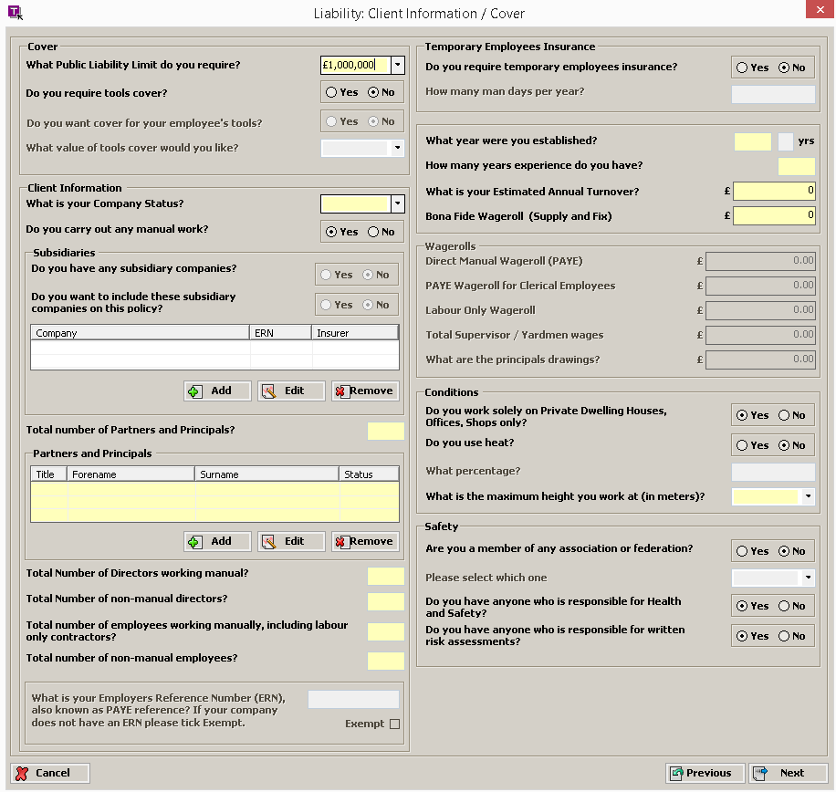

The following fields will be presented:

|  |  |  |
| --- | --- | --- |
| Field Heading | Comments | Ref |

**Cover**

|  |  |  |
| --- | --- | --- |
| What Public Liability Limit do you required? | LIST_MH_PUBLIAB (NEW)  Values: £1,000,000 £2,000,000 £5,000,000  Default value will be £1,000,000 |  |
| Do you require tools cover? | Yes / No option  Default value will be No |  |
| Do you want cover for your employee’s tools? | Yes / No option  Default value will be No |  |
| What value of tools cover would you like? | Disabled – see rules  LIST_MH_COVTOOLS (NEW)  Values: £500 £1,000 £1,250 £1,500 £2,500 £5,000 |  |

**Client Information**

|  |  |  |
| --- | --- | --- |
| What is your Company Status? | LIST_MH_COSTATUS (NEW)  Values: Partnership, Limited, Individual Trading As, Public Limited |  |
| Do you carry out any manual work | Disabled see rules  Radio button Yes/No  Default Value will be Yes |  |
| Do you have any subsidiary companies? | Yes / No option  Default value will be No |  |
| Do you want to include these subsidiary companies on this policy? | Yes / No option  Default value will be No |  |
| Total number of Partners and Principals | Disabled – see rules  5 numeric characters |  |
| Partners and Principals | Disabled – see rules  Summary View of all Partners and Principals held against the risk |  |
| Total number of Directors working manual? | Disabled see rule  3 numeric characters |  |
| Total number of non-manual directors? | Disabled see rule  3 numeric characters |  |
| Total number of employees working manually, including labour only contractors? | 5 numeric characters |  |
| Total number of NON MANUAL employees? | 5 numeric characters |  |
| What is your Employers Reference Number (ERN) also known as a PAYE reference? If your company does not have an ERN please tick Exempt | 20 numeric characters |  |

**Temporary Employees Insurance**

|  |  |  |
| --- | --- | --- |
| Do you require temporary employees insurance? | Yes / No option  Default value will be No |  |
| How many man days per year? | Disabled – see rules  3 numeric characters |  |

|  |  |  |
| --- | --- | --- |
| What year were you established? | 4 numeric characters, taking the format YYYY to represent 4 digit year |  |
| yrs | Disabled, calculated – see rules  2 numeric characters |  |
| How many years experience do you have? | Disabled – see rules  2 numeric characters |  |
| What is your Estimated Annual Turnover? | Currency to 0 decimal places |  |
| Bona Fide Wageroll (Supply and Fix) | Currency to 0 decimal places |  |

**Wagerolls**

|  |  |  |
| --- | --- | --- |
| Direct Manual Wageroll (PAYE) | Disabled – see rules  Currency to 0 decimal places |  |
| PAYE Wageroll for Clerical Employees | Disabled – see rules  Currency to 0 decimal places |  |
| Labour Only Wageroll | Disabled – see rules  Currency to 0 decimal places |  |
| Total Supervisor / Yardmen wages | Disabled – see rules  Currency to 0 decimal places |  |
| What are the principals drawings? | Disabled – see rules  Currency to 0 decimal places |  |

**Conditions**

|  |  |  |
| --- | --- | --- |
| Do you work solely on Private Dwelling Houses, Offices, Shops only? | Yes / No option  Default value will be Yes  RATING NOTE: If answer NO default answer to commercial premises |  |
| Do you use Heat? | Yes / No option  Default value will be No |  |
| What percentage? | Disabled – see rules  3 numeric characters |  |
| What is the max height you work at? (in Metres) | LIST_MH_MAXHEIGHT (NEW)  Values: 10, 15, Over 15 |  |

**Safety**

|  |  |  |
| --- | --- | --- |
| Are you a member of any association or federation? | Yes / No option |  |
| Please select which one | Disabled – see rules  LIST_MH_ASSOC_FED (NEW)  Values: Gas Safe, F.M.B., Master Craftsmen, N.F.B., N.I.C.E.I.C., Other |  |
| Does your business comply with HSE rules and regulations? | Yes / No option  Default value will be Yes | Updated Website Help Text:  If your business complies with HSE rules and regulations , please select “yes”. Otherwise tick “no” |
| Do you complete Risk Assessments & Method Statements where appropriate? | Yes / No option  Default value will be Yes | Updated Website Help Text:  If your business completes Risk Assessments & Method Statements where appropriate , please select “yes”. Otherwise tick “no” |

The following rules will be applied:

|  |  |
| --- | --- |
| **Rule** | **Ref** |

**Cover**

|  |  |
| --- | --- |
| Response of YES to ‘Do you require tools cover?’ will enable the ‘What value of tools cover do you require?’ field |  |

**Client Information**

|  |  |
| --- | --- |
| Response of ‘Partnership’ to ‘What is your Company Status? will enable the ‘Total number of Partners and Principals’ field |  |
| Response of ‘Individual trading as’ to ‘What is your Company Status? will enable the “Do you carry out any manual work” field |  |
| Response of ‘Limited or Public Limited’ to ‘What is your Company Status? will enable the “Total number of director working manually” and “Total number of non manual directors” fields |  |
| If the value held against ‘Total number of Partners and Principals’ is greater than 1, the ‘Partners and Principals’ groupbox is enabled – allowing maintenance of the Partner and Principal details. DEVELOPER |  |
| Response of YES to ‘Do you require temporary employees insurance?’ will enable the ‘How many man days per year?’ field |  |
| If the value held against or a combination of ‘Total number of manual employees, including labour only contractors’ and/or “Number of Partners/Principals” and/or Total directors working manually” and/or “Total number non manual directors and employees” is greater than ‘10’ the following fields are enabled: DEVELOPER   * Direct Manual Wageroll (PAYE) * PAYE Wageroll for Clerical Employees * Labour Only Wageroll * Total Supervisor / Yardmen wages * What are the principals drawings? |  |
| The value of the ‘yrs’ field is calculated as the ‘Personal Details / Cover Start Date / Year’ minus the ‘What year were you established?’ value. DEVELOPER |  |
| Where the ‘yrs’ field has a value of 0,1 or 2 then enable ‘How many years experience do you have?’ DEVELOPER |  |
| Attempting to leave this screen whilst the value against ‘Total number of Partners and Principals’ LESS ONE does not equal the number of ‘Partner and Principal’ items will result in the error message ‘Please validate Partners and Principals’, the user will not be able to leave the screen. DEVELOPER |  |

**Conditions:**

|  |  |
| --- | --- |
| Response of YES to ‘Do you use Heat?’ will enable the ‘What percentage?’ field |  |

**Safety**

|  |  |
| --- | --- |
| Response of YES to ‘Are you a member of any association or federation?’ will enable the ‘Please select which one’ field. |  |

**8.1.3 Subsidiaries – this is current disables**

Subsidiaries is a ‘Child’ screen and is presented when select ‘Add’ or ‘Edit’ from Client Information / Cover screen

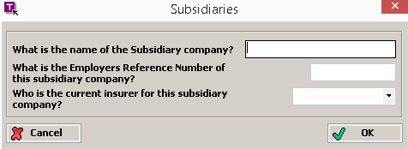

The following fields will be presented:

|  |  |  |
| --- | --- | --- |
| Field Heading | Comments | Ref |

|  |  |  |
| --- | --- | --- |
| What is the name of the Subsidiary company? | Alphanumeric characters |  |
| What is the Employers Reference Number of this subsidiary company? | 20 numeric characters |  |
| Who is the current insurer for this subsidiary company? | LIST_INSURER (ABI LIST 81)  **Values:** Standard ABI list |  |

### 8.1.4 Partners and Principals

Partners and Principals is a ‘Child’ screen and is presented when select ‘Add’ or ‘Edit’ from Client Information /Cover screen

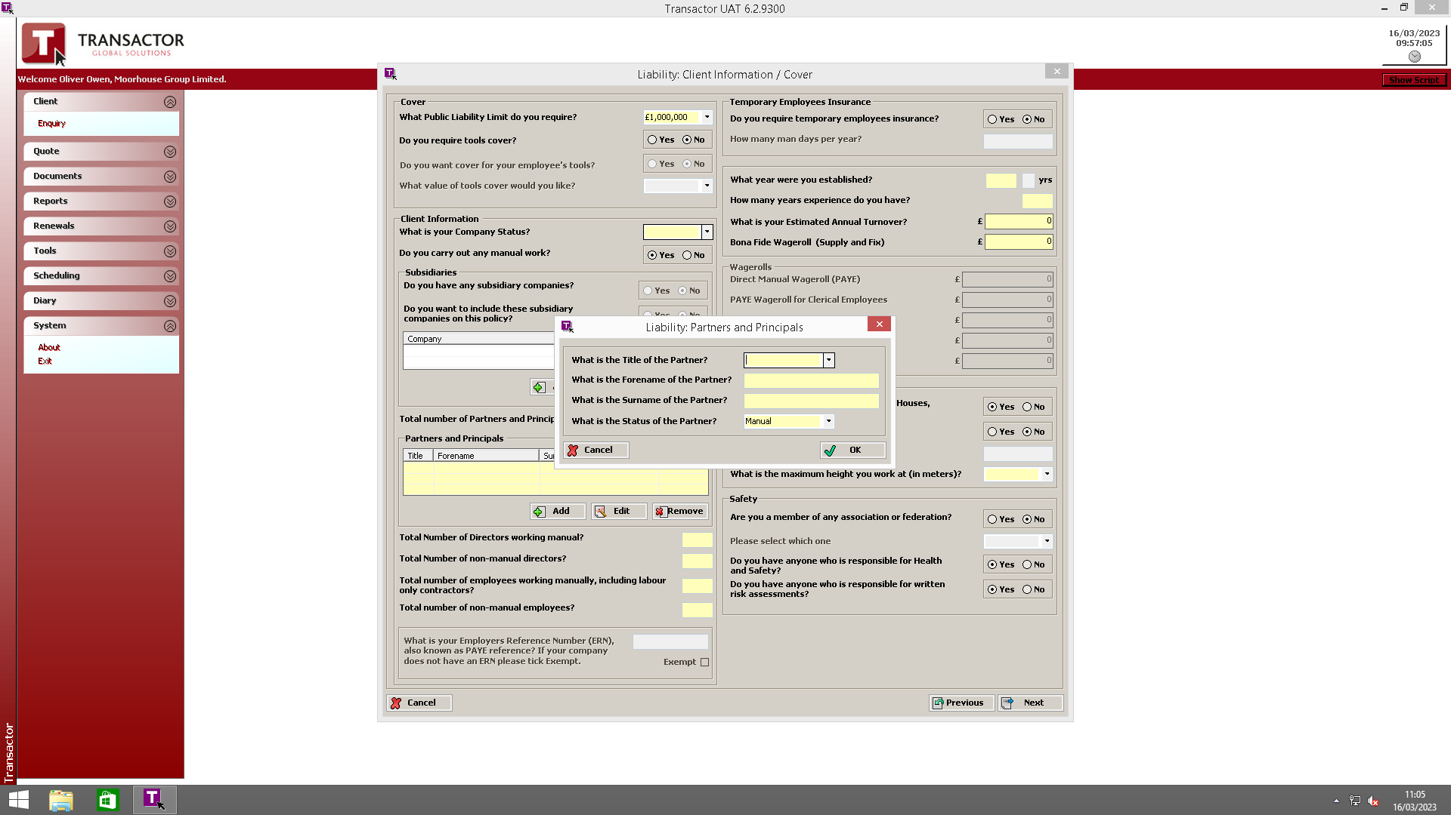

The following fields will be presented:

|  |  |  |
| --- | --- | --- |
| Field Heading | Comments | Ref |

|  |  |  |
| --- | --- | --- |
| What is the Title of the Partner? | LIST_TITLE (ABI LIST)  Values: Lord, Mis, Miss, Mr, Sir, Mrs | 796 |
| What is the Forename of the Partner? | 50 alphanumeric characters | 797 |
| What is the Surname of the Partner? | 50 alphanumeric characters | 798 |
| What is the Status of the Partner? | LIST_MH_P_STATUS (New)  Values: Manual, Non Manual  Default value will be Manual |  |

**8.1.5 Contractors All Risk**

Presented when select ‘Next’ from Client Information / Cover screen

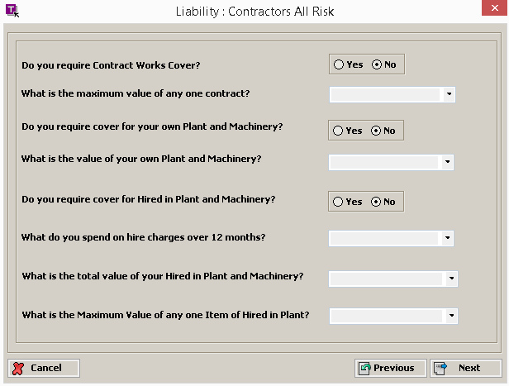

The following fields will be presented:

|  |  |  |
| --- | --- | --- |
| **Field Heading** | **Comments** | **Ref** |

|  |  |  |
| --- | --- | --- |
| Do you require Contract Works Cover? | Yes / No option  Default value will be No |  |
| What is the maximum value of any one contract? | List of values |  |
| Do you require cover for your own Plant and Machinery? | Yes / No option  Default value will be No |  |
| What is the value of your own Plant and Machinery? | List of values |  |
| Do you require cover for Hired in Plant and Machinery? | Yes / No option  Default value will be No |  |
| What do you spend on hire charges over 12 months? | List of values |  |
| What is the total value of your Hired in Plant and Machinery? | List of values |  |
| What is the Maximum Value of any one Item of Hired in Plant? | List of values |  |

**8.1.6 Personal Accident and Income Protection**

Presented when select ‘Next’ from Contractors All Risk screen

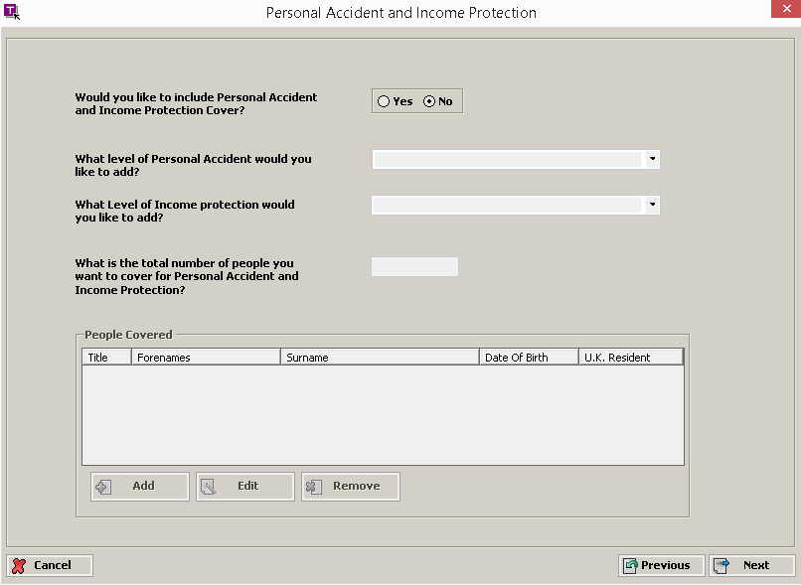

The following fields will be presented:

|  |  |  |
| --- | --- | --- |
| **Field Heading** | **Comments** | **Ref** |

|  |  |  |
| --- | --- | --- |
| Would you like to include Personal Accident and Income Protection cover? | Yes / No option  Default value will be No |  |
| What level of Personal Accident would you like to add? | List of values |  |
| What Level of Income protection would you like to add? | List of values |  |
| What is the total number of people you want to cover for Personal Accident and Income Protection? | Numeric characters |  |
| People Covered | Summary of all people covered by PAIP |  |

**8.1.7 Professional Indemnity**

Presented when select ‘Next’ from Personal Accident and Income Protection screen

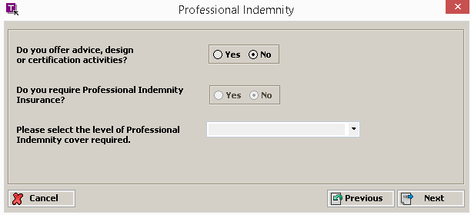

|  |  |  |
| --- | --- | --- |
| **Field Heading** | **Comments** | **Ref** |

|  |  |  |
| --- | --- | --- |
| Do you offer advice, design or certification activities? | Yes / No option  Default value will be No |  |
| Do you require Professional Indemnity Insurance? | Yes / No option  Default value will be No |  |
| Please select the level of Professional Indemnity cover required. | List of values |  |

**8.1.8 Claim Summary**

Presented when select ‘Next’ from Professional Indemnity screen

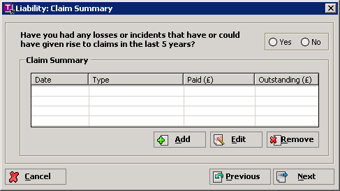

The following fields will be presented:

|  |  |  |
| --- | --- | --- |
| **Field Heading** | **Comments** | **Ref** |

|  |  |  |
| --- | --- | --- |
| Have you had any losses or incidents that have or could have given rise to claims in the last 5 years? | Yes / No option  Default value will be No | 452 |
| Claims Summary | Disabled – see rules  Summary View of any Claims |  |

The following rules will be applied:

|  |  |
| --- | --- |
| **Rule** | **Ref** |

|  |  |
| --- | --- |
| Response of YES to ‘Have you had any Public or Employers Liability or tools claims in the last five years?’ will enable all fields in the Claim Summary groupbox | 464 |
| Attempting to leave this screen whilst ‘Have you had ...’ is YES and the number of ‘Claim Summary’ items is 0 will result in the error message ‘Please validate Claims’, the user will not be able to leave the screen. DEVELOPER |  |

### Claim Detail

Claim Detail is a ‘Child’ screen and is presented when select ‘Add’ or ‘Edit’ from Claim Summary screen

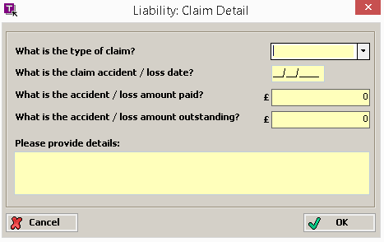

The following fields will be presented:

|  |  |  |
| --- | --- | --- |
| **Field Heading** | **Comments** | **Ref** |

|  |  |  |
| --- | --- | --- |
| What is the type of claim? | LIST_ MH_CLAIMTYPE (NEW)  **Values:** EL – Personal Injury, Third Party Damage, Third Party Injury, Tools | 791 |
| What is the claim accident / loss date? | Date taking the format dd/mm/yyyy  Date must be on or before cover start date | 776 |
| What is the accident / loss amount paid? | Currency to 0 decimal places | 777 |
| What is the accident / loss amount outstanding? | Currency to 0 decimal places | 778 |
| Please provide details: | 500 alphanumeric characters, with RETURNS accepted | 185 |

### Assumptions

The ‘Assumptions’ screen is the last in the series of risk data capture screens:

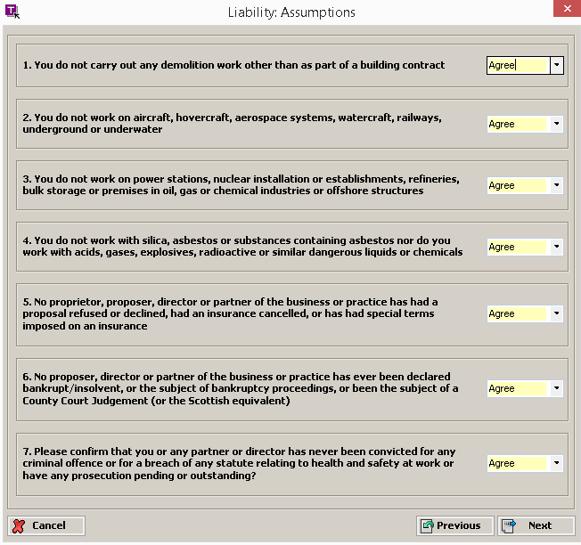

Transactor Navigator will be used to default all back office assumptions to take a value of ‘Agree’

The following fields will be presented:

|  |  |  |
| --- | --- | --- |
| **Field Heading** | **Comments** | **Ref** |

|  |  |  |
| --- | --- | --- |
| 1. You do not carry out any demolition work other than as part of a building contract | LIST_MH_ASSUMPT (**NEW**)  **Values:** Agree, Disagree  Default value will be ‘Agree’ |  |
| 2. You do not work on aircraft, hovercraft, aerospace systems, watercraft, railways, underground or underwater | LIST_MH_ASSUMPT (**NEW**)  **Values:** Agree, Disagree  Default value will be ‘Agree’ |  |
| 3. You do not work on power stations, nuclear installation or establishments, refineries, bulk storage or premises in oil, gas or chemical industries or offshore structures | LIST_MH_ASSUMPT (**NEW**)  **Values:** Agree, Disagree  Default value will be ‘Agree’ |  |
| 4. You do not work with silica, asbestos or substances containing asbestos nor do you work with acids, gases, explosives, radioactive or similar dangerous liquids or chemicals | LIST_MH_ASSUMPT (**NEW**)  **Values:** Agree, Disagree  Default value will be ‘Agree’ |  |
| 5. No proprietor, proposer, director or partner of the business or practice has had a proposal refused or declined, had an insurance cancelled, or has had special terms imposed on an insurance | LIST_MH_ASSUMPT (**NEW**)  **Values:** Agree, Disagree  Default value will be ‘Agree’ |  |
| 6. No proposer, director or partner of the business or practice has ever been declared bankrupt / insolvent, or the subject of bankruptcy proceedings, or been the subject of a County Court Judgement (or the Scottish equivalent) | LIST_MH_ASSUMPT (**NEW**)  **Values:** Agree, Disagree  Default value will be ‘Agree’ |  |
| 7. Please confirm that you or any partner or director has never been convicted for any criminal offence or for a breach of any statute relating to health and safety at work or have any prosecution pending or outstanding? | LIST_MH_ASSUMPT (**NEW**)  **Values:** Agree, Disagree  Default value will be ‘Agree’ |  |
| 8. Please confirm that you conduct ongoing staff training to all employees, and this training is documented/recorded | LIST_MH_ASSUMPT (**NEW**)  **Values:** Agree, Disagree  Default value will be ‘Agree’ |  |
| 9. Please confirm that PPE (Personal Protective Equipment) is issued to all employees who require it and the process if fully documented and reviewed | LIST_MH_ASSUMPT (**NEW**)  **Values:** Agree, Disagree  Default value will be ‘Agree’ |  |